* A link to the GitHub repository containing the code for your project.

<https://github.com/SheCodesAus/she-codes-crowdfunding-api-project-NimaBanga.git>

* A link to the deployed project.

<https://empty-cherry-5374.fly.dev/projects/>

* A screenshot of Insomnia, demonstrating a successful GET method for any endpoint.

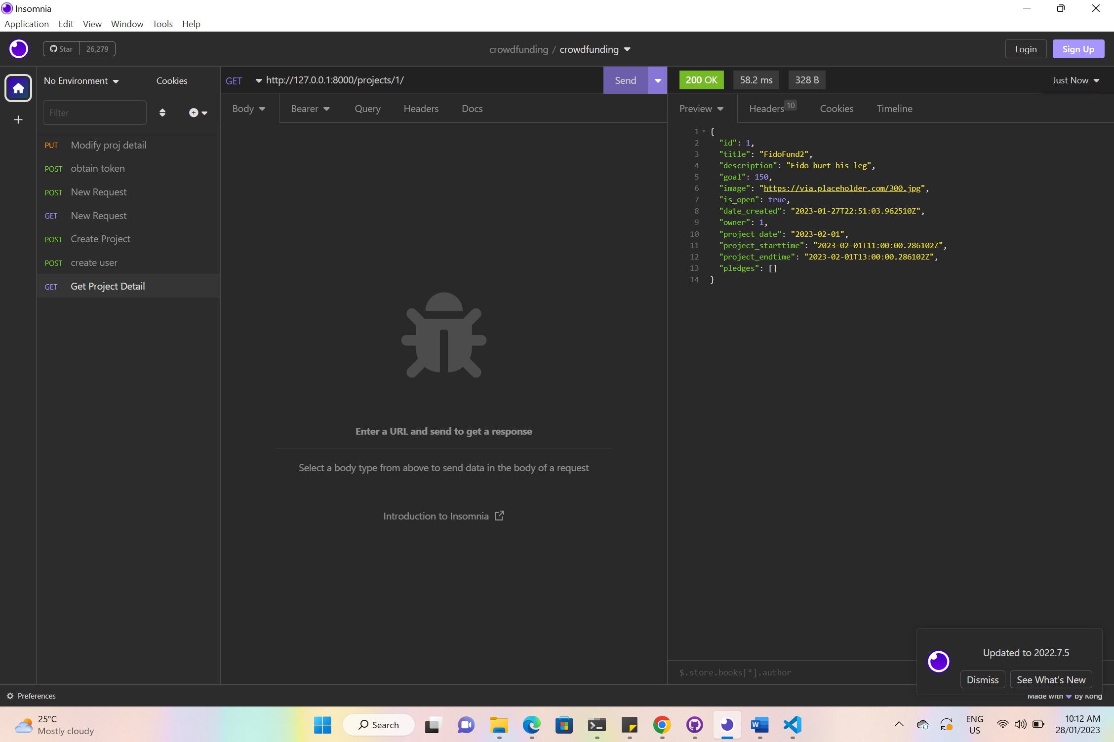

* A screenshot of Insomnia, demonstrating a successful POST method for any endpoint.

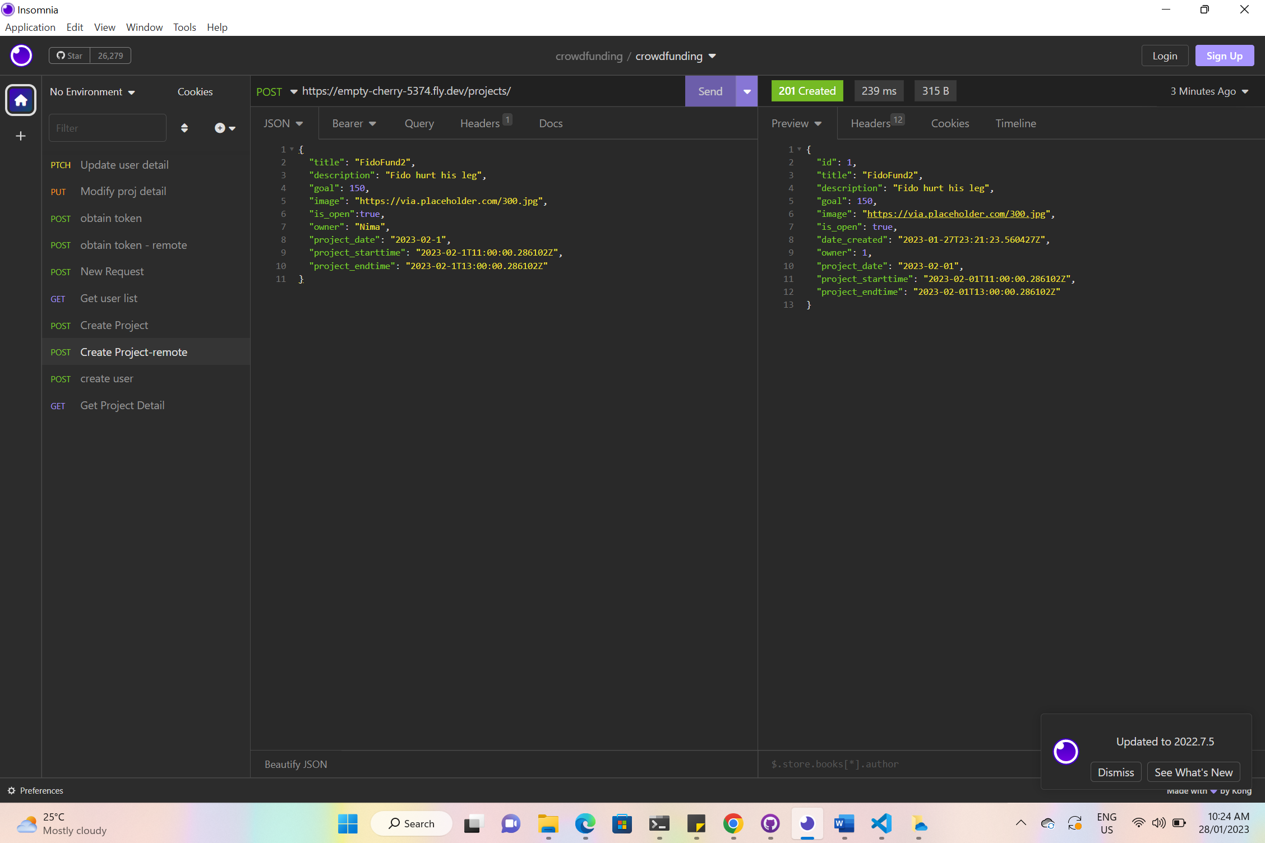

* A screenshot of Insomnia, demonstrating a token being returned.

* Step by step instructions for how to register a new user and create a new project (i.e.end points and body data).

Create a new user:

End point: <http://127.0.0.1:8000/users/>

Body:

{

"username": "nimabanga1",

"email": "nimartachugh@gmail.com",

"password": "greatday",

"first_name": "Nima",

"last_name": "Banga",

"bio": "tadaaaa",

"photo": "https://images.app.goo.gl/kyvPFVnseeuvWXwq6",

"address": "23 Sophia Cres, North Rocks, NSW 2151"

}

Create a new project:

End point: <http://127.0.0.1:8000/projects/>

Body:

{

"id": 1,

"title": "Bush clean up",

"description": "Bush clean up in North Rocks Dam",

"goal": 20,

"image": "https://images.app.goo.gl/kyvPFVnseeuvWXwq6",

"is_open": true,

"date_created": "2023-01-28T00:31:19.687583Z",

"owner": 1,

"project_date": "2023-01-31",

"project_starttime": "2023-01-31T10:00:00Z",

"project_endtime": "2023-01-31T12:00:00Z",

"project_location": "North Rocks Dam",

"pledges": [

{

"id": 1,

"pledge_time": true,

"comment": "So excited to meet new mates",

"project": 1,

"supporter": 1,

"pledge_date": "2023-01-28T00:31:52.908679Z"

}

* Your refined API specification and Database Schema.

In the excel file in the repository